
Faculty of Computing Information
Trimester 2510

CIT 6234 Advanced Database
Assignment 2

NoSQL Data Warehouse for Online Grocery System

Lecture Session: TC1L / Tutorial Session: TT2L
Student Name | Student ID
Ku Jing Hao | 1201203310
Lim Jun Jie | 1201103290
Lim Sir Yuean | 1211307746
Yap Jack | 1211103024

Contents
Part A 3
1. Construct Document-Based Data Modeling Representation 3
Data Dictionary 5
3. Create Database and Respective Collections 7
3.1 Database and Collection Creation 7
3.2 Collection Constraints 8
4. Enter Sample Data into Collection 15
5. Construct NoSQL 36
5.1 One query with Logical operation (AND, OR, NOT) 36
5.2 One query with Comparison operator (greater than, greater than and equal, less than, etc) 39
5.3 Aggregrate function (sum, average, max, min, count) 41
5.4 One query with project command 42
5.5 One query with size clause 45
6. Update Particular Records Based on Certain Criteria 47
7. Delete Specific records Based on Certain Criteria 50
8. Two NoSQL Commands Not Covered in Lecture 52
8.1 Advanced Supplier Performance Analytics with Text Search 52
8.2 Customer Behavior Analytics with Advanced Array Operations 54
Part B 57
Title : The Impact of Big Data on the Online Grocery Industry 57

Part A

1. Construct Document-Based Data Modeling Representation
Sales {
_id:
total_unit_ordered:
total_price:
total_discount:
total_net_price:
total_revenue:
order_date:
deliv_address:
pay_method:
pay_status:

Customer:{
cus_id:
cus_name:
cus_dob:
cus_email:
cus_phoneNum:
cus_address:
cus_registration_date:
cus_loyalty_tier:
}

Supplier:[
{
supp_id: SUPP-0
supp_name:
supp_email:
supp_phoneNum:
supp_country:

Product:[
{
prod_name:
prod_category:
prod_unit_price:
prod_available_stock:
prod_unit_ordered:
},
{
prod_name:
prod_category:
prod_unit_price:
prod_available_stock:
prod_unit_ordered:
}
]
},
{
supp_id: SUPP-1
supp_name:
supp_email:
supp_phoneNum:
supp_country:

Product:[
{
prod_name:
prod_category:
prod_unit_price:
prod_available_stock:
prod_unit_ordered:
},
{
prod_name:
prod_category:
prod_unit_price:
prod_available_stock:
prod_unit_ordered:
}
]
}
]

Promotion:[
{
promo_id: PROMO-0
promo_name:
promo_start_date:
promo_end_date:
promo_type:
promo_value:
promo_min_purchase:
},
{
promo_id: PROMO-1
promo_name:
promo_start_date:
promo_end_date:
promo_type:
promo_value:
promo_min_purchase:
}
]
}

Data Dictionary
Collections Name | Object Name | Data Type | Unique
Sales | _id | ObjectId | True
 | total_unit_ordered | Int
 | total_price | Double
 | total_discount | Double
 | total_net_price | Double
 | total_revenue | Double
 | order_date | Date
 | deliv_address | String
 | pay_method | String
 | pay_status | String
 | Customer | Object
 | Supplier | Array
 | Promotion | Array
Customer | cus_id | String
 | cus_name | String
 | cus_dob | Date
 | cus_email | String
 | cus_phoneNum | String
 | cus_address | String
 | cus_registration_date | Date
 | cus_loyalty_tier | Int
Supplier | supp_id | String
 | supp_name | String
 | supp_email | String
 | supp_phoneNum | String
 | supp_country | String
 | Product | Array
Product | prod_name | String
 | prod_category | String
 | prod_unit_price | Double
 | prod_available_stock | Int
 | prod_unit_ordered | Int
Promotion | promo_id | String
 | promo_name | String
 | promo_start_date | Date
 | promo_end_date | Date
 | promo_type | String
 | promo_value | Double
 | promo_min_purchase | Double

3. Create Database and Respective Collections

3.1 Database and Collection Creation
You can create a database by running a command that creates and switches to a new database called DW_OnlineGrocerySys, or by clicking the 'Create Database' button in MongoDB Compass.
use DW_OnlineGrocerySys

With a sales collection using the following command:
db.createCollection("Sales")

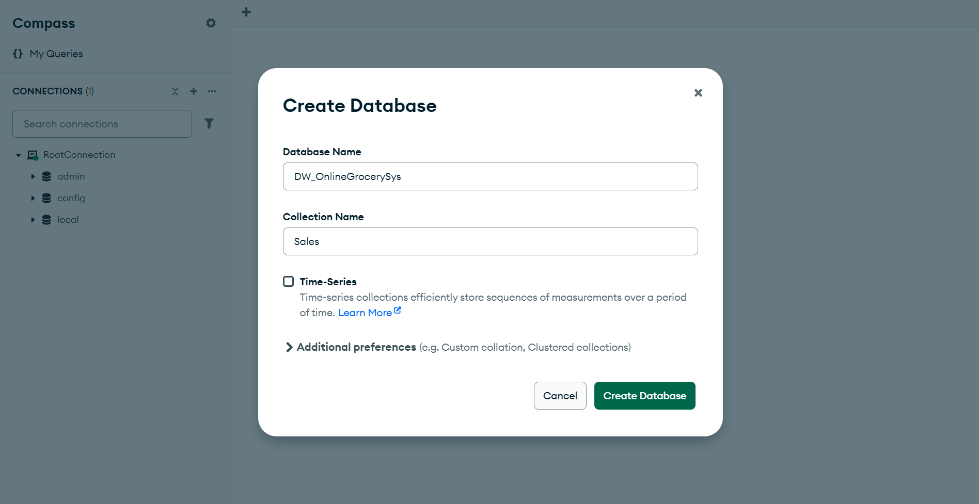
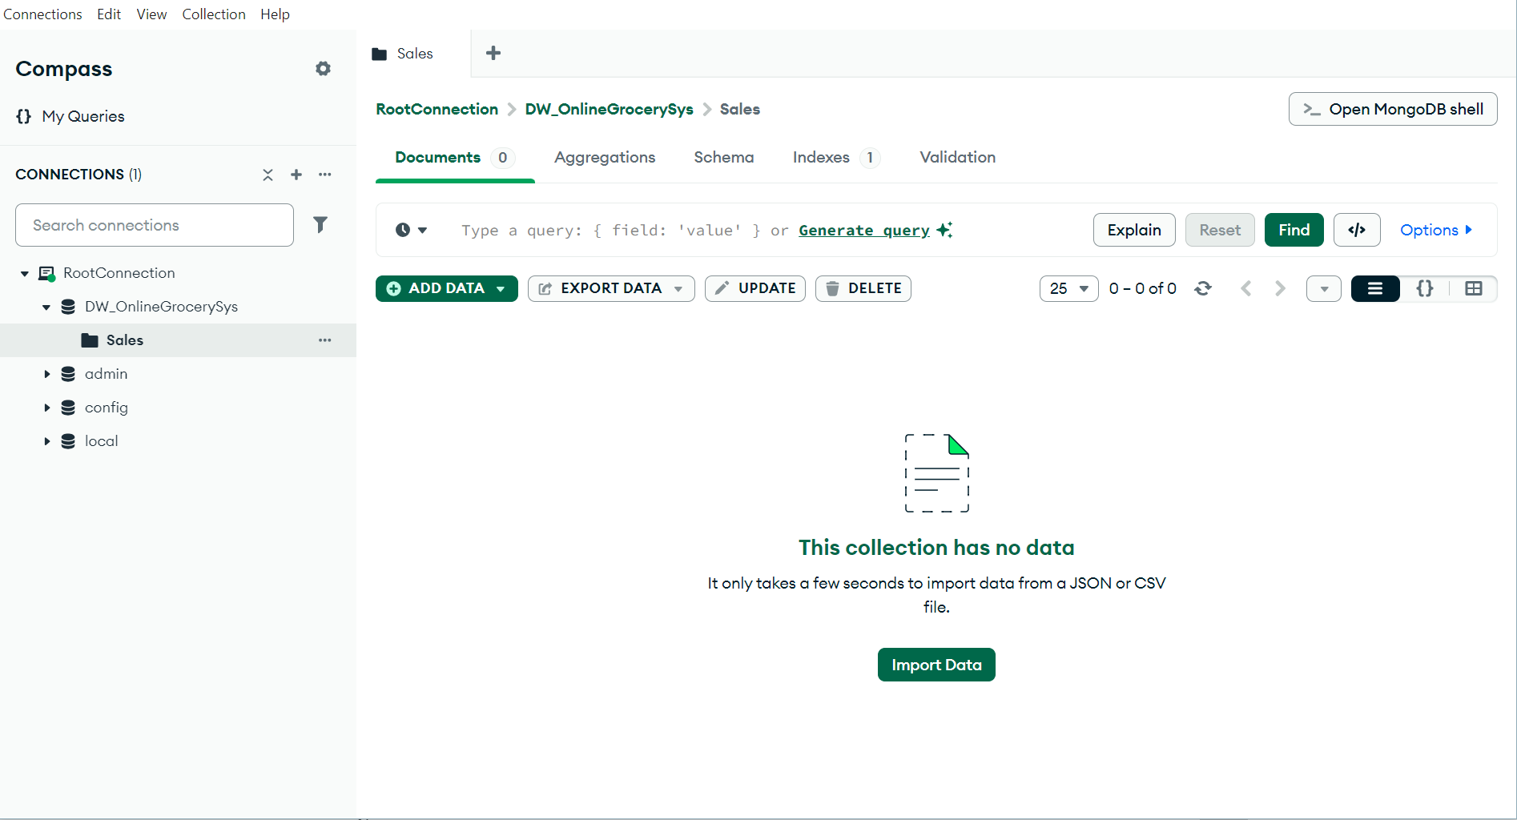

3.2 Collection Constraints
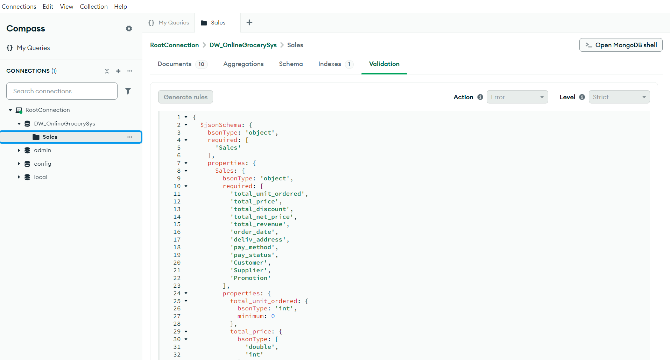
{
$jsonSchema: {
bsonType: 'object',
required: [
'Sales'
],
properties: {
Sales: {
bsonType: 'object',
required: [
'total_unit_ordered',
'total_price',
'total_discount',
'total_net_price',
'total_revenue',
'order_date',
'deliv_address',
'pay_method',
'pay_status',
'Customer',
'Supplier',
'Promotion'
],
properties: {
total_unit_ordered: {
bsonType: 'int',
minimum: 0
},
total_price: {
bsonType: [
'double',
'int'
],
minimum: 0
},
total_discount: {
bsonType: [
'double',
'int'
],
minimum: 0
},
total_net_price: {
bsonType: [
'double',
'int'
],
minimum: 0
},
total_revenue: {
bsonType: [
'double',
'int'
],
minimum: 0
},
order_date: {
bsonType: 'date'
},
deliv_address: {
bsonType: 'string'
},
pay_method: {
bsonType: 'string'
},
pay_status: {
'enum': [
'Completed',
'Cancelled'
]
},
Customer: {
bsonType: 'object',
required: [
'cus_id',
'cus_name',
'cus_dob',
'cus_email',
'cus_registration_date',
'cus_loyalty_tier'
],
properties: {
cus_id: {
bsonType: 'string'
},
cus_name: {
bsonType: 'string'
},
cus_dob: {
bsonType: 'date'
},
cus_email: {
bsonType: 'string',
pattern: '^.+@.+\\..+$'
},
cus_phoneNum: {
bsonType: 'string',
pattern: '^\\d{3}-\\d{3} \\d{4}$'
},
cus_address: {
bsonType: 'string'
},
cus_registration_date: {
bsonType: 'date'
},
cus_loyalty_tier: {
bsonType: 'int',
minimum: 1,
maximum: 3
}
}
},
Supplier: {
bsonType: 'array',
items: {
bsonType: 'object',
required: [
'supp_id',
'supp_name',
'supp_email',
'supp_phoneNum',
'supp_country',
'Product'
],
properties: {
supp_id: {
bsonType: 'string'
},
supp_name: {
bsonType: 'string'
},
supp_email: {
bsonType: 'string',
pattern: '^.+@.+\\..+$'
},
supp_phoneNum: {
bsonType: 'string',
pattern: '^\\d{3}-\\d{3} \\d{4}$'
},
supp_country: {
bsonType: 'string'
},
Product: {
bsonType: 'array',
items: {
bsonType: 'object',
required: [
'prod_name',
'prod_category',
'prod_unit_price',
'prod_available_stock',
'prod_unit_ordered'
],
properties: {
prod_name: {
bsonType: 'string'
},
prod_category: {
bsonType: 'string'
},
prod_unit_price: {
bsonType: [
'double',
'int'
],
minimum: 1
},
prod_available_stock: {
bsonType: 'int',
minimum: 0
},
prod_unit_ordered: {
bsonType: 'int',
minimum: 1
}
}
}
}
}
}
},
Promotion: {
bsonType: 'array',
items: {
bsonType: 'object',
required: [
'promo_id',
'promo_name',
'promo_start_date',
'promo_end_date',
'promo_type',
'promo_value',
'promo_min_purchase'
],
properties: {
promo_id: {
bsonType: 'string'
},
promo_name: {
bsonType: 'string'
},
promo_start_date: {
bsonType: 'date'
},
promo_end_date: {
bsonType: 'date'
},
promo_type: {
bsonType: 'string'
},
promo_value: {
bsonType: [
'double',
'int'
],
minimum: 0
},
promo_min_purchase: {
bsonType: [
'double',
'int'
],
minimum: 0
}
}
}
}
}
}
}
}
}

4. Enter Sample Data into Collection
[
{
"Sales": {
"total_unit_ordered": 9,
"total_price": 159.8,
"total_discount": 65.5,
"total_net_price": 94.3,
"total_revenue": 94.3,
"order_date": {
"$date": "2023-02-22"
},
"deliv_address": "Address D",
"pay_method": "Digital Wallet",
"pay_status": "Completed",
"Customer": {
"cus_id": "CUS-4",
"cus_name": "CUS_D",
"cus_dob": {
"$date": "1996-01-01"
},
"cus_email": "cusD@gmail.com",
"cus_phoneNum": "014-444 4444",
"cus_address": "Home Address D",
"cus_registration_date": {
"$date": "2022-11-17"
},
"cus_loyalty_tier": 2
},
"Supplier": [
{
"supp_id": "SUPP-10",
"supp_name": "Company J",
"supp_email": "jjj@gmail.com",
"supp_phoneNum": "111-000 0000",
"supp_country": "Malaysia",
"Product": [
{
"prod_name": "Product A",
"prod_category": "Category A",
"prod_unit_price": 25.75,
"prod_available_stock": 57,
"prod_unit_ordered": 4
}
]
},
{
"supp_id": "SUPP-5",
"supp_name": "Company E",
"supp_email": "eee@gmail.com",
"supp_phoneNum": "222-555 5555",
"supp_country": "Singapore",
"Product": [
{
"prod_name": "Product J",
"prod_category": "Category B",
"prod_unit_price": 11.36,
"prod_available_stock": 69,
"prod_unit_ordered": 5
}
]
}
],
"Promotion": [
{
"promo_id": "PROMO-1",
"promo_name": "Promotion A1",
"promo_start_date": {
"$date": "2023-02-28"
},
"promo_end_date": {
"$date": "2024-04-10"
},
"promo_type": "Type A",
"promo_value": 45.5,
"promo_min_purchase": 50.0
},
{
"promo_id": "PROMO-11",
"promo_name": "Promotion A2",
"promo_start_date": {
"$date": "2023-01-20"
},
"promo_end_date": {
"$date": "2024-03-01"
},
"promo_type": "Type A",
"promo_value": 30.33,
"promo_min_purchase": 15.5
}
]
}
},
{
"Sales": {
"total_unit_ordered": 2,
"total_price": 28.78,
"total_discount": 25.0,
"total_net_price": 3.78,
"total_revenue": 3.78,
"order_date": {
"$date": "2023-03-01"
},
"deliv_address": "Address D",
"pay_method": "Debit",
"pay_status": "Completed",
"Customer": {
"cus_id": "CUS-8",
"cus_name": "CUS_H",
"cus_dob": {
"$date": "1979-02-02"
},
"cus_email": "cusH@gmail.com",
"cus_phoneNum": "018-888 8888",
"cus_address": "Home Address D",
"cus_registration_date": {
"$date": "2023-07-25"
},
"cus_loyalty_tier": 2
},
"Supplier": [
{
"supp_id": "SUPP-10",
"supp_name": "Company J",
"supp_email": "jjj@gmail.com",
"supp_phoneNum": "111-000 0000",
"supp_country": "Malaysia",
"Product": [
{
"prod_name": "Product I",
"prod_category": "Category C",
"prod_unit_price": 14.9,
"prod_available_stock": 17,
"prod_unit_ordered": 2
}
]
}
],
"Promotion": [
{
"promo_id": "PROMO-2",
"promo_name": "Promotion F",
"promo_start_date": {
"$date": "2023-02-20"
},
"promo_end_date": {
"$date": "2024-03-14"
},
"promo_type": "Type D",
"promo_value": 25.0,
"promo_min_purchase": 20.5
}
]
}
},
{
"Sales": {
"total_unit_ordered": 7,
"total_price": 175.25,
"total_discount": 90.5,
"total_net_price": 84.75,
"total_revenue": 0.0,
"order_date": {
"$date": "2023-04-29"
},
"deliv_address": "Address A",
"pay_method": "Bank",
"pay_status": "Cancelled",
"Customer": {
"cus_id": "CUS-1",
"cus_name": "CUS_A",
"cus_dob": {
"$date": "1980-03-03"
},
"cus_email": "cusA@gmail.com",
"cus_phoneNum": "011-111 1111",
"cus_address": "Home Address A",
"cus_registration_date": {
"$date": "2022-01-20"
},
"cus_loyalty_tier": 1
},
"Supplier": [
{
"supp_id": "SUPP-2",
"supp_name": "Company B",
"supp_email": "bbb@gmail.com",
"supp_phoneNum": "222-222 2222",
"supp_country": "Singapore",
"Product": [
{
"prod_name": "Product D",
"prod_category": "Category B",
"prod_unit_price": 26.16,
"prod_available_stock": 51,
"prod_unit_ordered": 4
}
]
},
{
"supp_id": "SUPP-6",
"supp_name": "Company F",
"supp_email": "fff@gmail.com",
"supp_phoneNum": "111-666 6666",
"supp_country": "Malaysia",
"Product": [
{
"prod_name": "Product G",
"prod_category": "Category A",
"prod_unit_price": 29.48,
"prod_available_stock": 40,
"prod_unit_ordered": 2
}
]
},
{
"supp_id": "SUPP-5",
"supp_name": "Company E",
"supp_email": "eee@gmail.com",
"supp_phoneNum": "222-555 5555",
"supp_country": "Singapore",
"Product": [
{
"prod_name": "Product C",
"prod_category": "Category C",
"prod_unit_price": 11.65,
"prod_available_stock": 60,
"prod_unit_ordered": 1
}
]
}
],
"Promotion": [
{
"promo_id": "PROMO-2",
"promo_name": "Promotion B",
"promo_start_date": {
"$date": "2023-03-27"
},
"promo_end_date": {
"$date": "2024-06-14"
},
"promo_type": "Type B",
"promo_value": 50.0,
"promo_min_purchase": 45.5
},
{
"promo_id": "PROMO-12",
"promo_name": "Promotion B2",
"promo_start_date": {
"$date": "2023-04-11"
},
"promo_end_date": {
"$date": "2024-05-01"
},
"promo_type": "Type B",
"promo_value": 30.5,
"promo_min_purchase": 15.0
},
{
"promo_id": "PROMO-22",
"promo_name": "Promotion B3",
"promo_start_date": {
"$date": "2023-04-01"
},
"promo_end_date": {
"$date": "2024-04-08"
},
"promo_type": "Type B",
"promo_value": 10.0,
"promo_min_purchase": 7.5
}
]
}
},
{
"Sales": {
"total_unit_ordered": 5,
"total_price": 63.88,
"total_discount": 29.5,
"total_net_price": 34.38,
"total_revenue": 34.38,
"order_date": {
"$date": "2024-02-09"
},
"deliv_address": "Address A",
"pay_method": "Digital Wallet",
"pay_status": "Completed",
"Customer": {
"cus_id": "CUS-5",
"cus_name": "CUS_E",
"cus_dob": {
"$date": "1990-04-04"
},
"cus_email": "cusE@gmail.com",
"cus_phoneNum": "013-333 3333",
"cus_address": "Home Address C",
"cus_registration_date": {
"$date": "2022-10-20"
},
"cus_loyalty_tier": 2
},
"Supplier": [
{
"supp_id": "SUPP-10",
"supp_name": "Company J",
"supp_email": "jjj@gmail.com",
"supp_phoneNum": "111-000 0000",
"supp_country": "Malaysia",
"Product": [
{
"prod_name": "Product I",
"prod_category": "Category C",
"prod_unit_price": 14.9,
"prod_available_stock": 17,
"prod_unit_ordered": 2
}
]
},
{
"supp_id": "SUPP-05",
"supp_name": "Company E",
"supp_email": "eee@gmail.com",
"supp_phoneNum": "222-555 5555",
"supp_country": "Singapore",
"Product": [
{
"prod_name": "Product J",
"prod_category": "Category C",
"prod_unit_price": 11.36,
"prod_available_stock": 61,
"prod_unit_ordered": 3
}
]
}
],
"Promotion": [
{
"promo_id": "PROMO-4",
"promo_name": "Promotion D",
"promo_start_date": {
"$date": "2024-01-02"
},
"promo_end_date": {
"$date": "2024-02-16"
},
"promo_type": "Type D",
"promo_value": 29.5,
"promo_min_purchase": 30.0
}
]
}
},
{
"Sales": {
"total_unit_ordered": 4,
"total_price": 105.3,
"total_discount": 45.5,
"total_net_price": 59.8,
"total_revenue": 59.8,
"order_date": {
"$date": "2024-02-16"
},
"deliv_address": "Address A",
"pay_method": "Digital Wallet",
"pay_status": "Completed",
"Customer": {
"cus_id": "CUS-9",
"cus_name": "CUS_I",
"cus_dob": {
"$date": "1980-05-05"
},
"cus_email": "cusI@gmail.com",
"cus_phoneNum": "019-999 9999",
"cus_address": "Home Address A",
"cus_registration_date": {
"$date": "2023-10-09"
},
"cus_loyalty_tier": 2
},
"Supplier": [
{
"supp_id": "SUPP-8",
"supp_name": "Company H",
"supp_email": "hhh@gmail.com",
"supp_phoneNum": "111-888 8888",
"supp_country": "United States",
"Product": [
{
"prod_name": "Product H",
"prod_category": "Category C",
"prod_unit_price": 26.9,
"prod_available_stock": 22,
"prod_unit_ordered": 2
}
]
},
{
"supp_id": "SUPP-10",
"supp_name": "Company J",
"supp_email": "jjj@gmail.com",
"supp_phoneNum": "111-000 0000",
"supp_country": "Malaysia",
"Product": [
{
"prod_name": "Product A",
"prod_category": "Category A",
"prod_unit_price": 25.75,
"prod_available_stock": 53,
"prod_unit_ordered": 2
}
]
}
],
"Promotion": [
{
"promo_id": "PROMO-5",
"promo_name": "Promotion C",
"promo_start_date": {
"$date": "2024-01-22"
},
"promo_end_date": {
"$date": "2024-03-02"
},
"promo_type": "Type C",
"promo_value": 25.5,
"promo_min_purchase": 20.0
},
{
"promo_id": "PROMO-15",
"promo_name": "Promotion C2",
"promo_start_date": {
"$date": "2024-02-15"
},
"promo_end_date": {
"$date": "2024-02-20"
},
"promo_type": "Type C",
"promo_value": 20.0,
"promo_min_purchase": 15.0
}
]
}
},
{
"Sales": {
"total_unit_ordered": 3,
"total_price": 80.94,
"total_discount": 30.5,
"total_net_price": 50.44,
"total_revenue": 0.0,
"order_date": {
"$date": "2024-06-05"
},
"deliv_address": "Address C",
"pay_method": "Credit",
"pay_status": "Cancelled",
"Customer": {
"cus_id": "CUS-3",
"cus_name": "CUS_C",
"cus_dob": {
"$date": "1990-06-06"
},
"cus_email": "cusC@gmail.com",
"cus_phoneNum": "013-333 3333",
"cus_address": "Home Address C",
"cus_registration_date": {
"$date": "2022-10-20"
},
"cus_loyalty_tier": 2
},
"Supplier": [
{
"supp_id": "SUPP-6",
"supp_name": "Company F",
"supp_email": "fff@gmail.com",
"supp_phoneNum": "111-666 6666",
"supp_country": "Malaysia",
"Product": [
{
"prod_name": "Product E",
"prod_category": "Category C",
"prod_unit_price": 26.98,
"prod_available_stock": 94,
"prod_unit_ordered": 3
}
]
}
],
"Promotion": [
{
"promo_id": "PROMO-6",
"promo_name": "Promotion E",
"promo_start_date": {
"$date": "2024-06-02"
},
"promo_end_date": {
"$date": "2024-06-29"
},
"promo_type": "Type C",
"promo_value": 30.5,
"promo_min_purchase": 35.5
}
]
}
},
{
"Sales": {
"total_unit_ordered": 4,
"total_price": 92.5,
"total_discount": 40.5,
"total_net_price": 51.65,
"total_revenue": 51.65,
"order_date": {
"$date": "2024-07-02"
},
"deliv_address": "Address D",
"pay_method": "Bank",
"pay_status": "Completed",
"Customer": {
"cus_id": "CUS-7",
"cus_name": "CUS_G",
"cus_dob": {
"$date": "1979-07-07"
},
"cus_email": "cusG@gmail.com",
"cus_phoneNum": "017-777 7777",
"cus_address": "Home Address C",
"cus_registration_date": {
"$date": "2023-07-14"
},
"cus_loyalty_tier": 1
},
"Supplier": [
{
"supp_id": "SUPP-10",
"supp_name": "Company J",
"supp_email": "jjj@gmail.com",
"supp_phoneNum": "111-000 0000",
"supp_country": "Malaysia",
"Product": [
{
"prod_name": "Product A",
"prod_category": "Category A",
"prod_unit_price": 25.75,
"prod_available_stock": 51,
"prod_unit_ordered": 3
},
{
"prod_name": "Product I",
"prod_category": "Category C",
"prod_unit_price": 14.9,
"prod_available_stock": 15,
"prod_unit_ordered": 1
}
]
}
],
"Promotion": [
{
"promo_id": "PROMO-7",
"promo_name": "Promotion H",
"promo_start_date": {
"$date": "2024-07-01"
},
"promo_end_date": {
"$date": "2024-08-31"
},
"promo_type": "Type C",
"promo_value": 40.5,
"promo_min_purchase": 30.5
}
]
}
},
{
"Sales": {
"total_unit_ordered": 6,
"total_price": 72.2,
"total_discount": 25.5,
"total_net_price": 46.7,
"total_revenue": 0.0,
"order_date": {
"$date": "2024-08-07"
},
"deliv_address": "Address A",
"pay_method": "Bank",
"pay_status": "Cancelled",
"Customer": {
"cus_id": "CUS-10",
"cus_name": "CUS_J",
"cus_dob": {
"$date": "1979-08-08"
},
"cus_email": "cusJ@gmail.com",
"cus_phoneNum": "000-000 0000",
"cus_address": "Home Address A",
"cus_registration_date": {
"$date": "2023-12-12"
},
"cus_loyalty_tier": 2
},
"Supplier": [
{
"supp_id": "SUPP-4",
"supp_name": "Company D",
"supp_email": "ddd@gmail.com",
"supp_phoneNum": "222-444 4444",
"supp_country": "Singapore",
"Product": [
{
"prod_name": "Product F",
"prod_category": "Category A",
"prod_unit_price": 12.18,
"prod_available_stock": 58,
"prod_unit_ordered": 4
}
]
},
{
"supp_id": "SUPP-5",
"supp_name": "Company E",
"supp_email": "eee@gmail.com",
"supp_phoneNum": "222-555 5555",
"supp_country": "Singapore",
"Product": [
{
"prod_name": "Product C",
"prod_category": "Category C",
"prod_unit_price": 11.65,
"prod_available_stock": 33,
"prod_unit_ordered": 2
}
]
}
],
"Promotion": [
{
"promo_id": "PROMO-8",
"promo_name": "Promotion G",
"promo_start_date": {
"$date": "2024-08-17"
},
"promo_end_date": {
"$date": "2024-08-27"
},
"promo_type": "Type A",
"promo_value": 25.5,
"promo_min_purchase": 15.5
},
{
"promo_id": "PROMO-18",
"promo_name": "Promotion G2",
"promo_start_date": {
"$date": "2024-07-29"
},
"promo_end_date": {
"$date": "2024-08-31"
},
"promo_type": "Type A",
"promo_value": 10.0,
"promo_min_purchase": 20.0
}
]
}
},
{
"Sales": {
"total_unit_ordered": 10,
"total_price": 128.86,
"total_discount": 50.5,
"total_net_price": 78.36,
"total_revenue": 78.36,
"order_date": {
"$date": "2024-09-09"
},
"deliv_address": "Address B",
"pay_method": "Digital Wallet",
"pay_status": "Completed",
"Customer": {
"cus_id": "CUS-2",
"cus_name": "CUS_B",
"cus_dob": {
"$date": "1980-09-09"
},
"cus_email": "cusB@gmail.com",
"cus_phoneNum": "333-333 3333",
"cus_address": "Home Address B",
"cus_registration_date": {
"$date": "2022-09-07"
},
"cus_loyalty_tier": 3
},
"Supplier": [
{
"supp_id": "SUPP-5",
"supp_name": "Company E",
"supp_email": "eee@gmail.com",
"supp_phoneNum": "222-555 5555",
"supp_country": "Singapore",
"Product": [
{
"prod_name": "Product J",
"prod_category": "Category B",
"prod_unit_price": 11.36,
"prod_available_stock": 58,
"prod_unit_ordered": 6
},
{
"prod_name": "Product C",
"prod_category": "Category C",
"prod_unit_price": 11.65,
"prod_available_stock": 33,
"prod_unit_ordered": 3
}
]
},
{
"supp_id": "SUPP-10",
"supp_name": "Company J",
"supp_email": "jjj@gmail.com",
"supp_phoneNum": "111-000 0000",
"supp_country": "Malaysia",
"Product": [
{
"prod_name": "Product A",
"prod_category": "Category A",
"prod_unit_price": 25.75,
"prod_available_stock": 48,
"prod_unit_ordered": 1
}
]
}
],
"Promotion": [
{
"promo_id": "PROMO-9",
"promo_name": "Promotion I",
"promo_start_date": {
"$date": "2024-09-01"
},
"promo_end_date": {
"$date": "2024-10-07"
},
"promo_type": "Type B",
"promo_value": 30.0,
"promo_min_purchase": 20.0
},
{
"promo_id": "PROMO-19",
"promo_name": "Promotion I2",
"promo_start_date": {
"$date": "2024-09-05"
},
"promo_end_date": {
"$date": "2024-10-30"
},
"promo_type": "Type A",
"promo_value": 10.5,
"promo_min_purchase": 20.0
},
{
"promo_id": "PROMO-29",
"promo_name": "Promotion I3",
"promo_start_date": {
"$date": "2024-09-03"
},
"promo_end_date": {
"$date": "2024-09-08"
},
"promo_type": "Type B",
"promo_value": 10.0,
"promo_min_purchase": 15.5
}
]
}
},
{
"Sales": {
"total_unit_ordered": 5,
"total_price": 74.5,
"total_discount": 20.5,
"total_net_price": 53.95,
"total_revenue": 0.0,
"order_date": {
"$date": "2024-10-17"
},
"deliv_address": "Address B",
"pay_method": "Credit",
"pay_status": "Cancelled",
"Customer": {
"cus_id": "CUS-6",
"cus_name": "CUS_F",
"cus_dob": {
"$date": "1977-10-10"
},
"cus_email": "cusG@gmail.com",
"cus_phoneNum": "017-777 7777",
"cus_address": "Home Address B",
"cus_registration_date": {
"$date": "2022-12-31"
},
"cus_loyalty_tier": 2
},
"Supplier": [
{
"supp_id": "SUPP-1",
"supp_name": "Company A",
"supp_email": "aaa@gmail.com",
"supp_phoneNum": "111-111 1111",
"supp_country": "Malaysia",
"Product": [
{
"prod_name": "Product B",
"prod_category": "Category C",
"prod_unit_price": 14.89,
"prod_available_stock": 48,
"prod_unit_ordered": 5
}
]
}
],
"Promotion": [
{
"promo_id": "PROMO-10",
"promo_name": "Promotion J",
"promo_start_date": {
"$date": "2024-10-15"
},
"promo_end_date": {
"$date": "2024-11-20"
},
"promo_type": "Type D",
"promo_value": 20.5,
"promo_min_purchase": 15.0
}
]
}
}
]

5. Construct NoSQL

5.1 One query with Logical operation (AND, OR, NOT)
This query is used in MongoDB Compass
Purpose: The purpose of this query is to identify high-value, completed sales transactions that meet specific business criteria for further analysis.
- Paid using ‘Debit’, ‘Bank’ or ‘Digital Wallet’
- Have payment status is complete
- Additionally, at least one of the following:
    - The order includes Category C products from Malaysian suppliers, and at least 4 units of those products were ordered
    - The total discount applied to the sale is greater than 20
Business Use: Target loyal, high-spending customers for future promotions or partnerships by analyzing completed sales transactions involving preferred payment methods and either bulk purchases of Category C products from local suppliers or significant discounts.
Logical Operators Used:
- $and : Combines multiple conditions that must all be true
- $or : Allows alternative conditions for payment methods and supplier/discount criteria
[
{
$match: {
$and: [
{
$or: [
{ "Sales.pay_method": "Debit" },
{ "Sales.pay_method": "Bank" },
{ "Sales.pay_method": "Digital Wallet" }
]
},
{ "Sales.pay_status": "Completed" },
{
$or: [
{
"Sales.Supplier": {
$elemMatch: {
supp_country: "Malaysia",
Product: {
$elemMatch: {
prod_category: "Category C",
prod_unit_ordered: { $gte: 4 }
}
}
}
}
},
{ "Sales.total_discount": { $gt: 20 } }
]
}
]
}
},
{
$unwind: "$Sales.Supplier"
},
{
$unwind: "$Sales.Supplier.Product"
},
{
$group: {
_id: "$Sales.Customer.cus_id",
total_revenue: { $sum: "$Sales.total_revenue" },
total_discount_given: { $sum: "$Sales.total_discount" },
products: {
$addToSet: "$Sales.Supplier.Product.prod_name"
},
countries: {
$addToSet: "$Sales.Supplier.supp_country"
},
num_orders: { $sum: 1 }
}
},
{
$sort: {
total_revenue: -1
}
}
]

Below is the output:
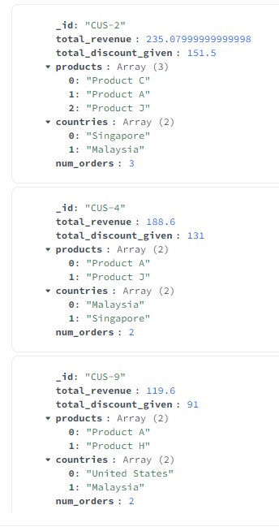

5.2 One query with Comparison operator (greater than, greater than and equal, less than, etc)
This query is used in MongoDB Compass
Purpose: This query targets completed, high-value sales (net price and revenue > 90) with moderate but significant discounts (20–75) where:
- Payment was made via Credit Card or Digital Wallet,
- Bulk orders of more than 4 units,
- Containing products from specific categories (A or B) ordered in bulk,
- Supplied by suppliers located in Malaysia or Singapore,
- Within recent sales (from 2023 onward),
- And where some promotion was applied.
Business Use: Identify premium customers who make substantial purchases with optimal discount ranges, helping businesses understand high-value transaction patterns and refine pricing strategies for customers who use preferred payment methods and purchase from regional suppliers.
Comparison Operator Used:
- $gte : Filters records greater than or equal to specified values for net price and dates
- $gt : Filters records greater than specified values for revenue, discount, and unit orders
- $lt : Filters records less than specified values for discount limits
{
$and: [
{ "Sales.pay_method": { $in: ["Credit Card", "Digital Wallet"] } },
{ "Sales.pay_status": "Completed"},
{ "Sales.total_net_price": { $gte: 90 } },
{ "Sales.total_revenue": { $gt: 90 } },
{ "Sales.total_discount": { $lt: 75 } },
{ "Sales.total_discount": { $gt: 20 } },
{ "Sales.total_unit_ordered": { $gt: 4 } },
{ "Sales.order_date": {
$gte: ISODate("2023-01-01T00:00:00.000+00:00") } },
{ "Sales.Supplier.Product": {
$elemMatch: {
$and: [
{ prod_unit_ordered: { $gt: 4 } },
{ prod_category: { $in: ["Category B", "Category A"] } }
]
}
}
},
{
"Sales.Supplier": {
$elemMatch: {
supp_country: {
$in: ["Malaysia", "Singapore"]
}
}
}
},
{
$or: [
{"Sales.Promotion": {$exists: true}}, {"Sales.Promotion": { $ne: []}}
]
}
]
}

Below is the output:
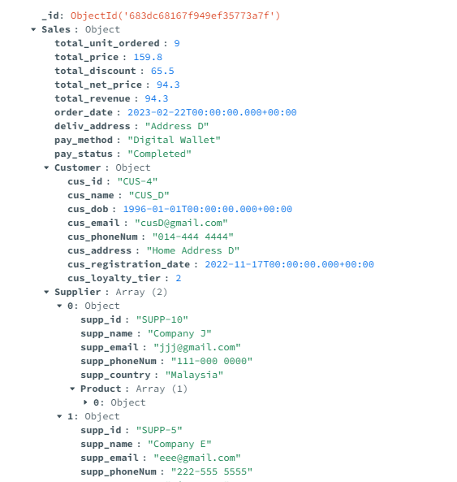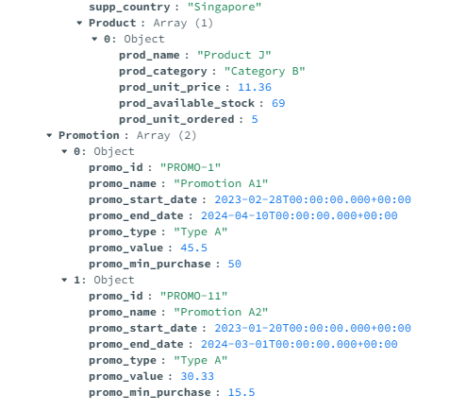

5.3 Aggregrate function (sum, average, max, min, count)
This query is used in MongoDB Compass
Purpose: This pipeline is used to analyze sales performance by customer loyalty tier, showing total revenue, average discount, and order count for each tier within a specific date range. It helps businesses understand which loyalty tiers generate the most revenue and how discounts affect sales. The pipeline first filters out sales that are complete and have a total revenue greater than 20. After that, it will filter out the customers that have a loyalty tier or at least 1.
Business Use: Understand which loyalty tiers generate the most revenue and how discounts affect sales, enabling businesses to optimize loyalty programs and discount strategies for different customer segments.
Aggregate Function Used:
- $sum : Calculates total revenue and counts orders for each loyalty tier
- $avg : Computes average discount values for each loyalty tier
[
{
$match: {
"Sales.pay_status": "Completed" ,
"Sales.total_revenue": { $gt: 20 },
"Sales.Customer.cus_loyalty_tier": { $gte: 1 },
"Sales.order_date": {
"$gte": ISODate("2022-01-01T00:00:00.000Z"),
"$lt": ISODate("2025-01-01T00:00:00.000Z")
}
}
},
{
$group: {
_id: "$Sales.Customer.cus_loyalty_tier",
total_revenue: { $sum: "$Sales.total_revenue" },
avg_discount: { $avg: "$Sales.total_discount" },
count_orders: { $sum: 1 }
}
},
{
$sort: { total_revenue: -1 }
}
]

Below is the output:
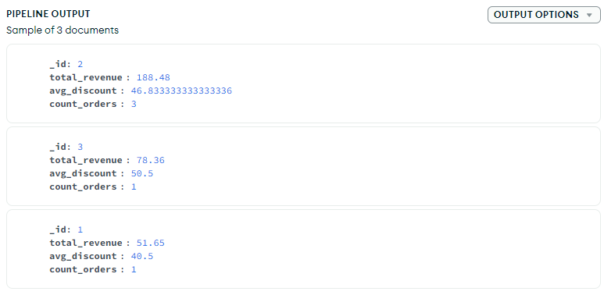

5.4 One query with project command
This query is used in MongoDB Compass
Purpose : The query selects all data from completed sales and returns customer details, what they purchased, and the promotions applied. Moreover, missing data is handled safely in the pipeline. It is valuable for making correct reports or dashboards that show how customers behave, what they buy and the influence of promotions. This query can also be used to support association rule analysis by revealing patterns between customer profiles, purchased products, and applied promotions.
Business Use: Create comprehensive reports or dashboards that show customer behavior, purchasing patterns, and promotion effectiveness, supporting association rule analysis by revealing patterns between customer profiles, purchased products, and applied promotions.
Function Used:
- $project : Reshapes documents to include only specified fields and computed values
[ { $match: { "Sales.pay_status": "Completed" } }, { $project: { _id: 0,
// Display customer info
cus_id: "$Sales.Customer.cus_id",
cus_name: "$Sales.Customer.cus_name",
cus_email: "$Sales.Customer.cus_email",
cus_loyalty_tier: "$Sales.Customer.cus_loyalty_tier",
// Product info (code below handles missing Supplier/Product)
products: {
$cond: {
// If Sales.Supplier is not empty, then return products.
if: { $gt: [{ $size: { $ifNull: ["$Sales.Supplier", []] } }, 0] },
then: {
$map: {
input: {
// Flatten the products of each supplier
$reduce: {
input: "$Sales.Supplier",
initialValue: [],
in: { $concatArrays: ["$$value", { $ifNull: ["$$this.Product", []] }] }
}
},
// only fetch values below.
as: "prod",
in: {
prod_name: "$$prod.prod_name",
prod_category: "$$prod.prod_category",
prod_unit_ordered: "$$prod.prod_unit_ordered"
}
}
},
else: []
}
},
// Promotion info (code below handles missing Promotion array)
promotions: {
$cond: {
// If Sales.Promotion is not empty, then return promo info.
if: { $gt: [{ $size: { $ifNull: ["$Sales.Promotion", []] } }, 0] },
then: {
$map: {
input: "$Sales.Promotion",
// only fetch values below.
as: "promo",
in: {
promo_name: "$$promo.promo_name",
promo_type: "$$promo.promo_type",
promo_value: "$$promo.promo_value"
}
}
},
else: []
}
}
}
} ]

Below is the output:
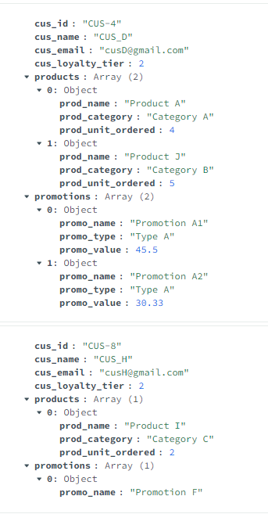

5.5 One query with size clause
This query is used in MongoDB Compass
Purpose: This aggregation pipeline finds sales records with more than one supplier. This pipeline filters through the sales records. After that, I will aggregate the supplier’s products. It can point out when several suppliers are involved in a transaction, which may potentially involve bulk orders, cross-vendor bundling, or complex supply chains. Businesses can use this insight to:
- Assess the complexity of procurement.
- Improve partnerships with your suppliers.
- Detect trends in multi-supplier sales behavior.
Business Use: Point out complex transactions involving bulk orders, cross-vendor bundling, or complex supply chains, helping businesses assess procurement complexity, improve supplier partnerships, and detect trends in multi-supplier sales behavior.
Function Used:
- $size : Counts the number of elements in the Supplier array
[
{
"$project": {
"_id": "$_id",
"number_of_suppliers": {
"$size": {
"$ifNull": ["$Sales.Supplier", []]
}
},
"suppliers": {
"$ifNull": ["$Sales.Supplier", []]
}
}
},
{
"$match": {
"number_of_suppliers": { "$gt": 1 }
}
},
{
"$unwind": "$suppliers"
},
{
"$unwind": "$suppliers.Product"
},
{
"$group": {
"_id": "$suppliers.supp_name",
"product_info": {
"$push": {
"product_name": "$suppliers.Product.prod_name",
"available_stock": "$suppliers.Product.prod_available_stock"
}
},
"total_products": {
"$sum": 1
},
"countries": {
"$addToSet": "$suppliers.supp_country"
}
}
},
{
"$sort": {
"total_products": -1
}
}
]

Below is the output:
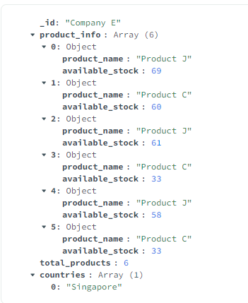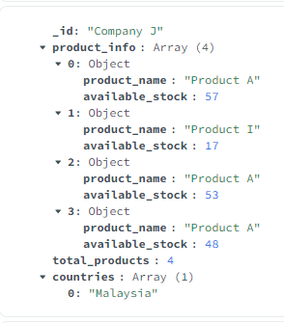

6. Update Particular Records Based on Certain Criteria
This query is used in MongoDB Shell
Criteria: Sales transactions with completed payment status and total revenue greater than 50, where customers have loyalty tier 2 or above, will receive a new voucher promotion to encourage future purchases.
Purpose: To reward high-value customers with completed transactions by adding voucher promotions that can be used for future purchases, thereby increasing customer retention and encouraging repeat business.
Business Use: This strategy helps maintain customer loyalty by providing additional value to premium customers who have demonstrated purchasing power. It supports customer lifetime value optimization and can lead to increased average order values in subsequent transactions.
db.Sales.updateMany(
{
$and: [
{ "Sales.pay_status": "Completed" },
{ "Sales.total_revenue": { $gt: 50 } },
{ "Sales.Customer.cus_loyalty_tier": { $gte: 2 } }
]
},
{
$push: {
"Sales.Promotion": {
promo_id: "PROMO-VOUCHER-20",
promo_name: "Voucher Promotion",
promo_start_date: new Date("2025-06-01"),
promo_end_date: new Date("2025-12-31"),
promo_type: "Type Voucher",
promo_value: 20.0,
promo_min_purchase: 0.0
}
}
}
)

Use this query to check how many records match the update criteria — this helps you estimate the number of records that will be affected by the updateMany() operation.
// Query to count updated records:

db.Sales.countDocuments({
$and: [
{ "Sales.pay_status": "Completed" },
{ "Sales.total_revenue": { $gt: 50 } },
{ "Sales.Customer.cus_loyalty_tier": { $gte: 2 } }
]
})

Use this find() query before the update (without the promo_id condition) to inspect eligible records, and after the update (with the promo_id filter) to verify which documents received the promotion.
// Query to verify affected records using find():
db.Sales.find(
{
$and: [
{ "Sales.pay_status": "Completed" },
{ "Sales.total_revenue": { $gt: 50 } },
{ "Sales.Customer.cus_loyalty_tier": { $gte: 2 } },
// Do not include the following line before the update, but you may include it after the update to verify that the promotion was successfully added.
{ "Sales.Promotion.promo_id": "PROMO-VOUCHER-20" }
]
},
{
"Sales.Customer.cus_name": 1,
"Sales.total_revenue": 1,
"Sales.Customer.cus_loyalty_tier": 1,
"Sales.Promotion": 1
}
)

Here is the Output:
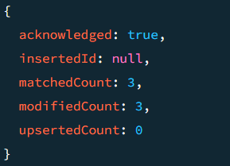
Before Update:
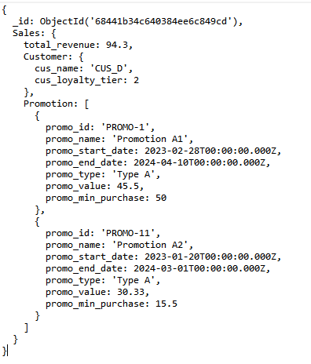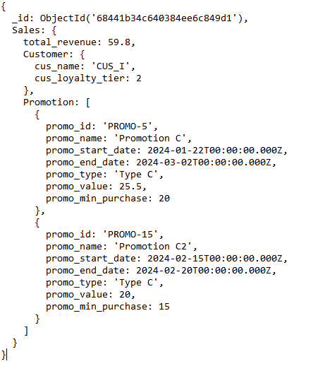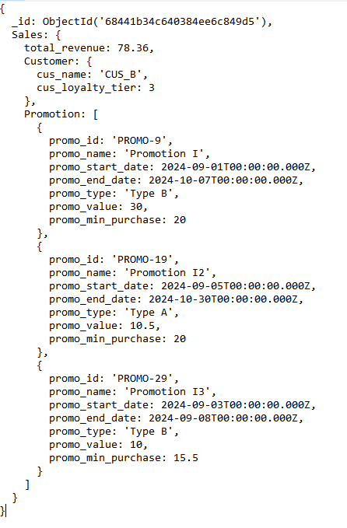

After Update:
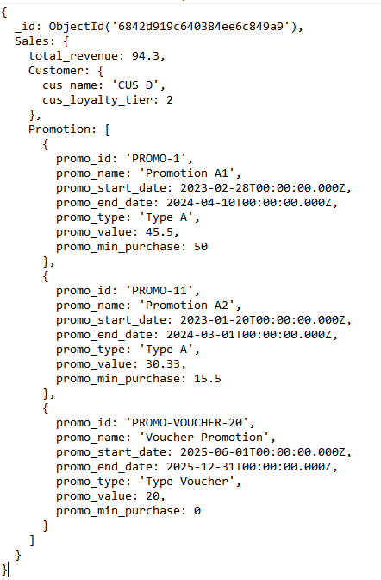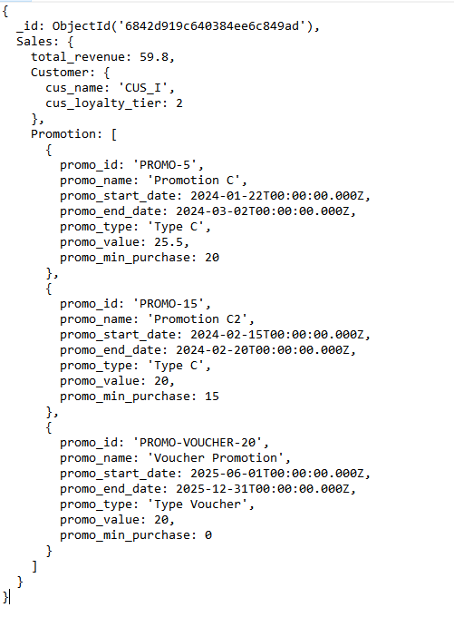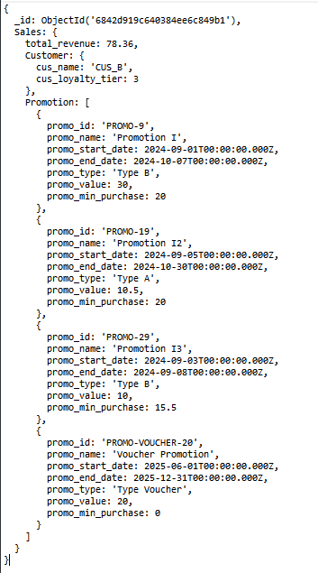

7. Delete Specific records Based on Certain Criteria
This query is used in MongoDB Shell
Criteria: Delete cancelled orders that are older than 1 year and have zero revenue to clean up historical data and maintain database performance.
Purpose: Database maintenance and storage optimization by removing outdated cancelled transactions that provide no business value for analysis or reporting.
Business Use: Data retention policy implementation that helps reduce storage costs, improve query performance, and maintain data quality by removing irrelevant cancelled orders while preserving important transactional history.
db.Sales.deleteMany(
{
$and: [
{ "Sales.pay_status": "Cancelled" },
{ "Sales.total_revenue": 0 },
{ "Sales.order_date": {
$lt: new Date(new Date().setFullYear(new Date().getFullYear() - 1))
}
}
]
}
)

Use this countDocuments() query to check how many sales records will be affected before performing the deleteMany() operation, and after deletion to confirm that no matching records remain.
db.Sales.countDocuments({
$and: [
{ "Sales.pay_status": "Cancelled" },
{ "Sales.total_revenue": 0 },
{ "Sales.order_date": {
$lt: new Date(new Date().setFullYear(new Date().getFullYear() - 1))
}
}
]
})

Here is the Output:
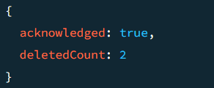

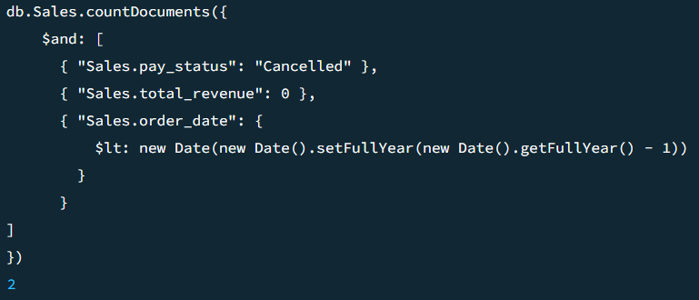
Before Delete:

After Delete:
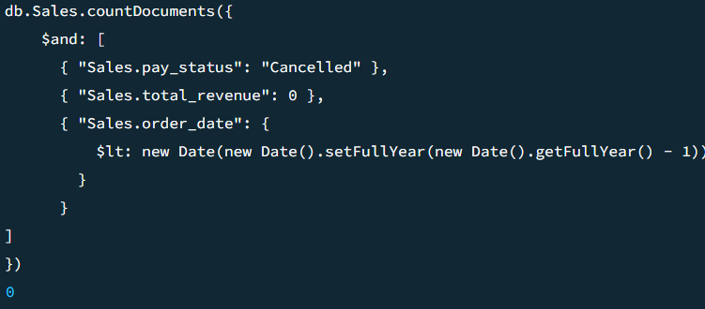

8. Two NoSQL Commands Not Covered in Lecture

8.1 Advanced Supplier Performance Analytics with Text Search
This query is used in MongoDB Compass
Purpose: This comprehensive supplier evaluation system analyzes supplier performance across multiple dimensions, identifying top-performing suppliers based on total revenue, average order value, and total product units sold. Additionally, it evaluates country-level performance by aggregating supplier participation and order counts by country. The query generates two results: one showing each supplier’s revenue metrics sorted by total revenue to highlight top earners, and another presenting supplier distribution by country, including the number of unique suppliers and total orders per region, enabling strategic insights into both individual supplier success and geographic market strength.
Business Use: Strategic supplier relationship management by identifying top-performing suppliers based on order volume, revenue contribution, and product diversity analysis.
Not Covered Functions used:
- $unwind: Flattens the Sales.Supplier and nested Product arrays for individual-level processing of each supplier and product.
- $facet: Enables parallel processing to generate two independent aggregations (supplier_revenue and country_performance) in one pipeline.
- $addToSet: Creates a set of unique supplier IDs per country to avoid duplicates in the supplier count.
[
{
$match: {
"Sales.pay_status": "Completed",
}
},
{
$unwind: "$Sales.Supplier"
},
{
$unwind: "$Sales.Supplier.Product"
},
{
$facet: {
"supplier_revenue": [
{
$group: {
_id: "$Sales.Supplier.supp_id",
supplier_name: { $first: "$Sales.Supplier.supp_name" },
total_revenue: { $sum: "$Sales.total_revenue" },
avg_order_value: { $avg: "$Sales.total_net_price" },
product_count: { $sum: "$Sales.Supplier.Product.prod_unit_ordered" }
}
},
{ $sort: { total_revenue: -1 } }
],
"country_performance": [
{
$group: {
_id: "$Sales.Supplier.supp_country",
suppliers_count: { $addToSet: "$Sales.Supplier.supp_id" },
total_orders: { $sum: 1 }
}
},
{
$project: {
country: "$_id",
unique_suppliers: { $size: "$suppliers_count" },
total_orders: 1
}
},
{ $sort: { total_orders: -1, unique_suppliers: -1 } }
]
}
}
]

Below is the output:
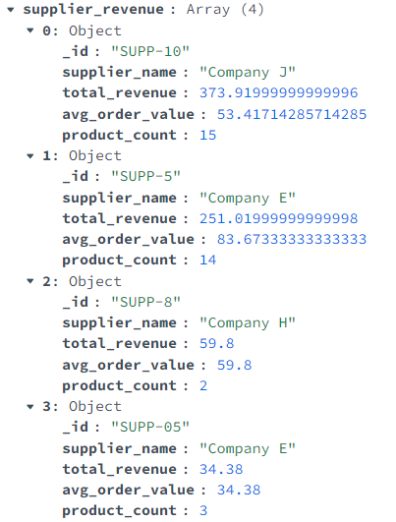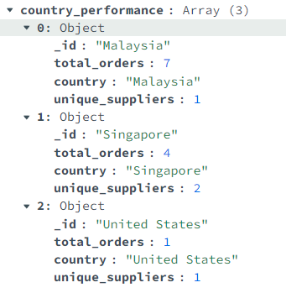

8.2 Customer Behavior Analytics with Advanced Array Operations
This query is used in MongoDB Compass
Purpose: Analyze customer purchase patterns by examining the variety and frequency of product categories purchased, identifying cross-selling opportunities.
- Filters sales transactions with payment status "Completed" only
- Unwinds nested supplier and product arrays for individual product analysis
- Groups customers by ID, name, and loyalty tier with key metrics calculation
- Calculates unique product categories, total orders, units ordered, and average order value
- Determines cross-selling potential: "High" for customers purchasing from fewer than 2 categories, indicating room to introduce them to other categories, "Low" for those with 2 or more categories, suggesting their buying behavior is already diversified
- Sorts results by category diversity (ascending) and total orders (descending) to prioritize high-value customers with greatest cross-selling opportunities
Business Use: Marketing intelligence system that helps identify customers' product preferences and purchasing diversity, enabling targeted marketing campaigns and personalized product recommendations for cross-selling strategies.
Not Covered Functions used:
- $match
- $unwind: Deconstructs Supplier and Product arrays to process each element individually
- $addToSet: Creates arrays of unique categories and products per customer
[
{
$match: {
"Sales.pay_status": "Completed",
}
},
{
$unwind: "$Sales.Supplier"
},
{
$unwind: "$Sales.Supplier.Product"
},
{
$group: {
_id: {
customer_id: "$Sales.Customer.cus_id",
customer_name: "$Sales.Customer.cus_name",
loyalty_tier: "$Sales.Customer.cus_loyalty_tier"
},
unique_categories: {
$addToSet: "$Sales.Supplier.Product.prod_category"
},
unique_products: {
$addToSet: "$Sales.Supplier.Product.prod_name"
},
total_orders: { $sum: 1 },
total_units: { $sum: "$Sales.Supplier.Product.prod_unit_ordered" },
avg_order_value: { $avg: "$Sales.total_net_price" }
}
},
{
$project: {
_id: 0,
customer_info: "$_id",
category_diversity: { $size: "$unique_categories" },
product_diversity: { $size: "$unique_products" },
categories_purchased: "$unique_categories",
total_orders: 1,
total_units: 1,
avg_order_value: { $round: ["$avg_order_value", 2] },
cross_sell_potential: {
$cond: {
if: { $lt: [{ $size: "$unique_categories" }, 2] },
then: "High",
else: "Low"
}
}
}
},
{
$sort: { category_diversity: 1, total_orders: -1 }
}
]

Below is the output:
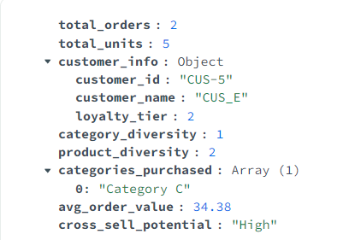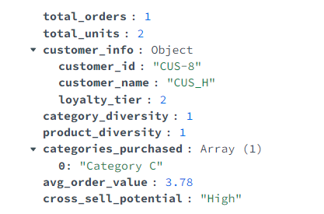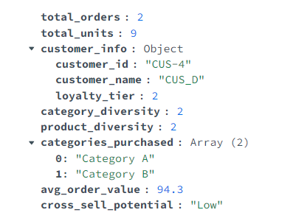
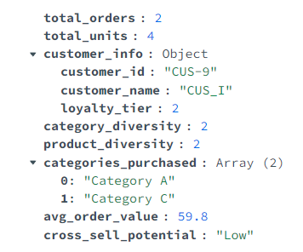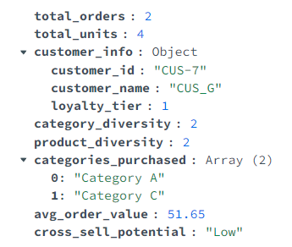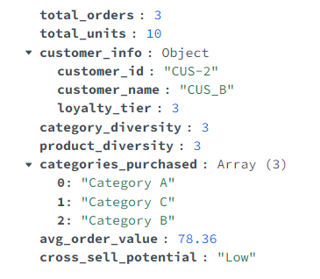

Part B

Title : The Impact of Big Data on the Online Grocery Industry
Big Data alludes to the large and diverse collection of structured and unstructured data exponentially generated by digital systems that can be analyzed to discover trends, patterns, and associations. (Cukier & Mayer-Schoenberger, 2013) In the online grocery industry, Big Data is extremely influential in optimizing customer experience, improving operational efficiency, and allowing data-driven decision-making.
Big Data enables personalized product recommendations for users based on their purchasing behavior, search history, and time of purchase. For instance, HappyFresh delegates its focus on building its first-party data-driven in-house advertising model to provide a personalized user purchasing journey including customer-centric marketing campaigns, retaining past users for future purchases. (Jain, 2025)
Furthermore, online grocers utilize Big Data for demand forecasting and inventory management, anticipating which products will be in-demand, waste reduction, and business losses. For example, Walmart’s inventory management exploits its precise inventory data from its massive consumer base to strike a balance between excessive and insufficient stock levels in response to fluctuating consumer demand, making sure goods are available for its online and offline stores. (Alexander et al., 2024)
Moreover, Big Data supports route and delivery optimization with traffic data, delivery schedules, and weather patterns. Case in point, Amazon Fresh analyzes efficient routes and distances to deliver packages to users faster. Additionally, weather conditions, delivery vehicles, geography, and available technologies were used to eliminate wasteful packaging and reduce shipment weight during deliveries. (Amazon, 2022)
In addition, Big Data empowers online grocers to conduct dynamic pricing by inspecting competitor prices, demand trends, and user purchasing patterns. Thus, an efficient pricing strategy could empower online grocers to stay competitive and boost sales. To illustrate, Walmart is replacing price stickers with digital shelf labels that could update prices remotely with real-time market observations, swiftly identify and discount perishable goods near expirations dates. (McMillen, 2024)
Big Data has permitted online grocers, from startups to global corporations, to achieve greater operational efficiency, personalized experience, and proactive pricing strategies. Its widespread application supports strategic decision-making across logistics, marketing, and inventory management. Besides, Big Data discovered new options to further optimize processes such as reducing packaging waste and delivery loads. However, concerns for data privacy are alarming as the data can be used to exploit users for more profit.
To summarize, Big Data drives efficiency, personalization, and sustainability for online grocers. An essential component for attaining competitive advantages and potential innovations through the use of informed decision-making in a data-driven market.

Citation
Alexander, J., Alexander, J., & Alexander, J. (2024, October 4). Walmart Inventory Management: A Comprehensive guide. SellerApp. https://www.sellerapp.com/blog/walmart-inventory-management/
Amazon. (2022). 2022 Amazon Sustainability Report. https://sustainability.aboutamazon.com/2022-sustainability-report.pdf’
Cukier, K., & Mayer-Schoenberger, V. (2013). The Rise of Big Data: How It’s Changing the Way We Think About the World. Foreign Affairs, 92(3), 28–40. http://www.jstor.org/stable/23526834
Jain, A. (2025, May 22). HappyFresh Business Model And How it Works in 2025. https://oyelabs.com. https://oyelabs.com/happyfresh-business-model/
McMillen, J. (2024, September 9). Walmart, Kroger and Whole Foods use digital pricing. What customers should know. Forbes. https://www.forbes.com/sites/jennmcmillen/2024/09/09/walmart-kroger-and-whole-foods-use-digital-pricing-what-customers-should-know/

